**Reading 1: The United Nations**

Franklin D. Roosevelt gave the name “United Nations” to the twenty-six nations that pledged in 1942 to fight together to defeat the Axis powers (Germany, Italy, and Japan) during [World War II](https://www2.gwu.edu/~erpapers/teachinger/glossary/world-war-2.cfm).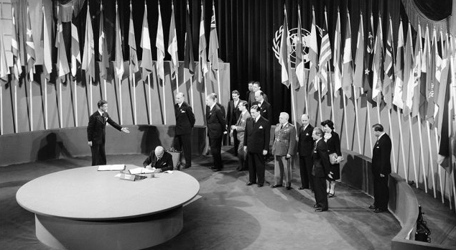

Planning for a permanent **international organization to keep the peace** began later and a preliminary plan was drawn up by the Great Powers (the United States, the Soviet Union, the United Kingdom, and China) in Washington, D.C. from August through October, 1944.

Fifty nations negotiated and signed the **United Nations Charter**, and it went into effect on **October 24, 1945.** October 24 continues to be celebrated as “United Nations Day.”

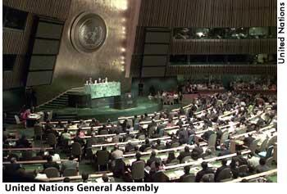Although FDR did not live to see the birth of the UN (he died on April 12, 1945), he was its principal architect. President [**Harry Truman**](https://www2.gwu.edu/~erpapers/teachinger/glossary/truman-harry.cfm) appointed Eleanor Roosevelt to the first American delegation to the UN. She became chairman of the [**UN Human Rights Commission**](https://www2.gwu.edu/~erpapers/teachinger/glossary/human-rights-commission.cfm) and guided the drafting of the [**Universal Declaration of Human Rights**](https://www2.gwu.edu/~erpapers/teachinger/glossary/udhr.cfm) and its adoption by the UN General Assembly. She regarded this work as her greatest achievement.

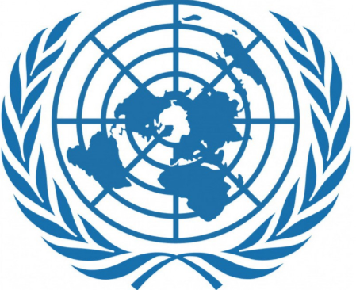

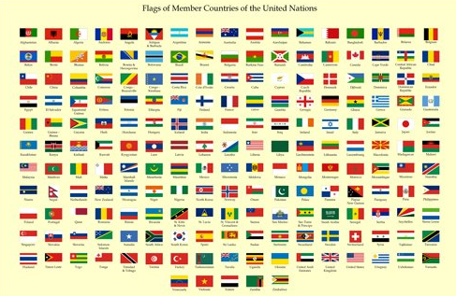The primary purposes of the United Nations are to **keep the peace,** **encourage respect for human rights, create conditions under which justice and respect for international laws and treaties can be achieved, and promote social progress and better standards of living throughout the world.** Its two principal representative bodies are the **General Assembly,** which includes all member nations, and the **Security Council**, which is made up of **five permanent members** (the United States, the Russian Federation, People's Republic of China, the United Kingdom, and France) and ten members elected by the General Assembly to two-year terms.

**Reading 2: Holocaust**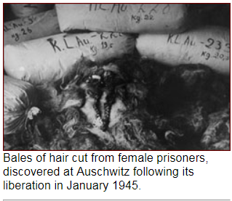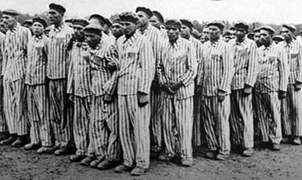

The **Holocaust** was the systematic state-sponsored killing of six million **Jewish** men, women, and children and millions of others by Nazi Germany and its collaborators during World War II. Germany was led by Adolf Hitler. Hitler blamed the Jews for losing WWI in 1918. He believed that in order to solve the world problems, he needed to get rid of the Jewish people (ethnic cleansing) and many other races of people that he didn't think were worthy. Over a decade of Nazi racist policies began around 1933 and lasted up to the final days of WWII. One policy was known as the “Final Solution” which was a Nazi plan for the mass genocide (killing) of Jews during World War II.

Hitler was the head of the political party called the **Nazis**. They were responsible for the murder of more than 6 million Jewish people during the Holocaust and millions of others, such as the Poles, gypsies and handicapped. All in all, historians estimate that Hitler and the Nazis murdered more than 11 million people. 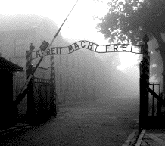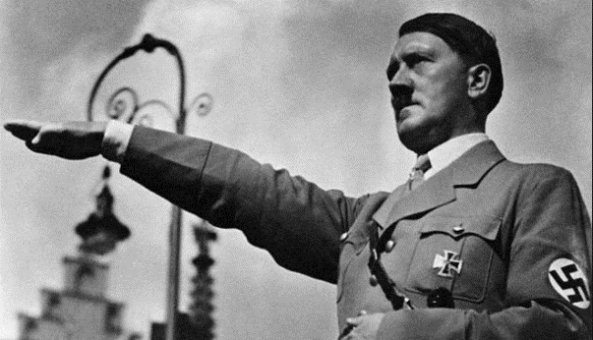

Nazis built huge **concentration camps (extermination camps)** in occupied Europe, where they would bring the Jews and other people they found unworthy to work and eventually die. The first of these concentration camps was called Dachau and was built in 1933. The Jews were told that they were going to be resettled, so most of them left without a fight. Some concentration camps built gas chambers, where countless Jews were killed. These camps became known as 'Death Camps.' The most infamous death camp was located outside of the city of Krakow, Poland, and was called Auschwitz. Over the course of the Holocaust, it was estimated that over 1 million people were murdered just in Auschwitz alone.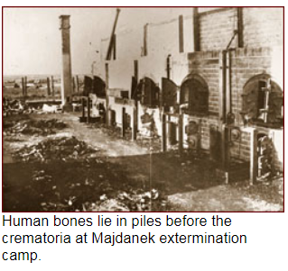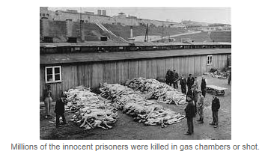

The Allies had knowledge about Nazi concentration camps about two and a half years prior to the ending of WWII. The United States and the other Allied nations prioritized **military victory** over **humanitarian considerations** during World War II. Saving Jews targeted for murder by the Nazi regime and its collaborators was not the Allies’ wartime aim.

**Reading 3: Nuremberg Trials**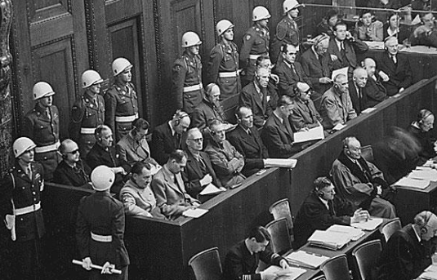

***Crimes against Peace, War Crimes, Crimes against Humanity***

In 1945 and 1946 **former leaders of**[**Nazi**](https://kids.britannica.com/kids/article/Nazi-Party/353523)**Germany** were put on trial for crimes committed during [World War II](https://kids.britannica.com/kids/article/World-War-II/353934). The trials were run by the countries that had defeated Germany in the war. They took place in Nuremberg, Germany. The court that held the trials was called the International Military Tribunal. **Judges from the United States, Great Britain, France, and the Soviet Union took part.**

**The Allies** eventually established the laws and procedures for the Nuremberg trials with the London Charter of the International Military Tribunal (IMT), issued on August 8, 1945. Among other things, the charter defined three categories of crimes: **crimes against peace** (including planning, preparing, starting or waging wars of aggression or wars in violation of international agreements), **war crimes** (including violations of customs or laws of war, including improper treatment of civilians and prisoners of war) and **crimes against humanity** (including murder, enslavement or deportation of civilians or persecution on political, religious or racial grounds). It was determined that civilian officials as well as military officers could be accused of war crimes. 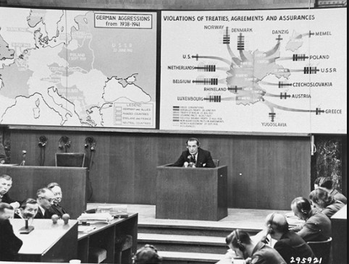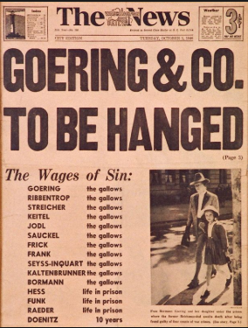

In the end, the international tribunal found all but three of the defendants guilty. **Twelve were sentenced to death**, one in absentia, and the rest were given **prison sentences** **ranging from 10 years to life behind bars.** Ten of the condemned were **executed by hanging** on October 16, 1946.

**Aftermath**

Nonetheless, most observers considered the **trials a step forward for the establishment of international law**. The findings at Nuremberg led directly to the **United Nations**[**Genocide**](https://www.history.com/topics/what-is-genocide)**Convention** (1948) and **Universal Declaration of Human** Rights (1948), as well as the [**Geneva Convention**](https://www.history.com/topics/geneva-convention) on the Laws and Customs of War (1949). In addition, the International Military Tribunal supplied a useful precedent for the trials of Japanese war criminals in [Tokyo](http://i.viglink.com/?key=1b475e2d3e085f0ff12aad1dcf010a10&insertId=1222c004deb90a0d&type=KW&exp=-1%3Ana%3A0&libId=js58cwnj0102pane000DAbvf18p2d&loc=https%3A%2F%2Fwww.history.com%2Ftopics%2Fworld-war-ii%2Fnuremberg-trials&v=1&iid=1222c004deb90a0d&opt=true&out=https%3A%2F%2Fwww.tripadvisor.com%2FHotels-g298184-Tokyo_Tokyo_Prefecture_Kanto-Hotels.html&ref=https%3A%2F%2Fwww.google.com%2F&title=Nuremberg%20Trials%20-%20HISTORY&txt=%3Cspan%3ETokyo%3C%2Fspan%3E) (1946-48); the 1961 trial of Nazi leader Adolf Eichmann (1906-62); and the establishment of tribunals for war crimes committed in the former Yugoslavia (1993) and in Rwanda (1994).

**Reading 4: UN and the Universal Declaration of Human Rights**

The United Nations (UN) came into being in 1945, shortly after the end of World War II. The stated purpose of the United Nations is to bring peace to all nations of the world. After World War II, a committee of persons headed by **Mrs. Eleanor Roosevelt,** the wife of US President Franklin D. Roosevelt, wrote a special document which “declares” the rights that everyone in the entire world should have—the Universal Declaration of Human Rights. Today there are 192 member states of the UN.

**Universal Declaration of Human Rights (simplified)**

**1. We Are All Born Free & Equal.** We are all born free. We all have our own thoughts and ideas. We should all be treated in the same way.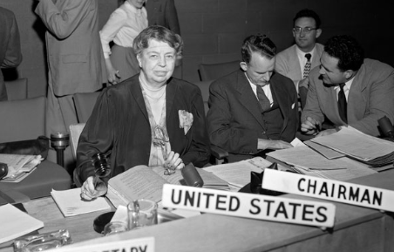

**2. Don’t Discriminate.** These rights belong to everybody, whatever our differences.

**3. The Right to Life.** We all have the right to life, and to live in freedom and safety.

**4. No Slavery.** Nobody has any right to make us a [slave](https://www.youthforhumanrights.org/what-are-human-rights/videos/no-slavery.html). We cannot make anyone our slave.

**5. No Torture**. Nobody has any right to hurt us or to torture us.

**6. You Have Rights No Matter Where You Go.** I am a person just like you!

**7. We’re All Equal Before the Law.**The law is the same for everyone. It must treat us all fairly.

**8. Your Human Rights Are Protected by Law.** We can all ask for the law to help us when we are not treated fairly.

…

**14. The Right to Seek a Safe Place to Live.** If we are frightened of being badly treated in our own country, we all have the right to run away to another country to be safe.

**15. Right to a Nationality.** We all have the right to belong to a country.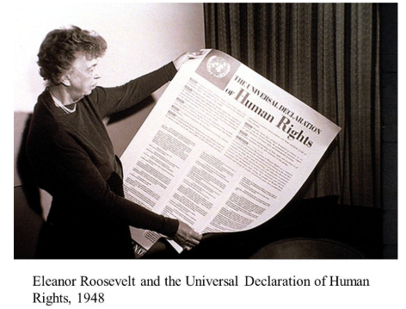

…

**28. A Fair and Free World.** There must be proper order so we can all enjoy rights and freedoms in our own country and all over the world.

**29. Responsibility.**We have a duty to other people, and we should protect their rights and freedoms.

**30. No One Can Take Away Your Human Rights.**

**Reading 1: The United Nations**

|  |
| --- |
| **How** did the United Nations form? |
| **When** did the U.N. officially begin? |
| What is the **purpose** of the United Nations? |
| **What role did the United States have in the overall creation of the U.N.?** |

**Reading 2: Holocaust**

|  |
| --- |
| What was the **Holocaust**? |
| Fully describe what a Nazi concentration camp was. |
| **Why do you think military victory** was **more important** to the allies than saving the Jews from Nazi extermination? |
| The United States admitted between 180,000 and 225,000 refugees who were fleeing Nazi persecution between 1933 and 1945. However, thousands more could have been granted US immigration visas had the quotas been filled during this period. **Why do you think the US denied thousands of Jewish refugees?** |

**Reading 3: Nuremberg Trials**

|  |
| --- |
| **What was the role of the United States in the Nuremberg Trials?** |
| Fully describe the 3 categories of crimes:   1. **Crimes against Peace:** 2. **War Crimes:** 3. **Crimes against Humanity:** |
| What was the consequence of those **found guilty**? |

**Reading 4: UN and the Universal Declaration of Human Rights**

|  |
| --- |
| What is the **Universal Declaration of Human Rights**? |
| **How** does the **outcome** of the Nuremberg Trials **support and/or contradict** the Universal Declaration of Human Rights? |
| Read through the rights provided in the text. If you could only be guaranteed 1 of them, **which one would it be and why?** |